SRS DOCUMENT – HACS

**BY**

**H. RAJESHWARI**

# 3 Functional Requirements

The generic guidelines applicable for all the functions of the Home Automation Control System (HACS) are:

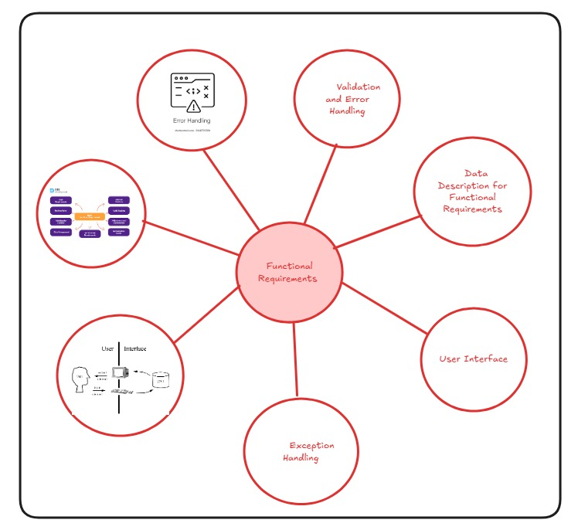

**Validation and Error Handling**

•**Users informed** of all **validation failures** (e.g., **invalid login**, **wrong temperature values**) with **clear error messages**.

·**System-generated data errors** (e.g., **incorrect sensor readings**) → **process aborted** and **error logged**.

·**User-input errors** (e.g., **invalid device name**, **wrong schedule time**) → **user allowed to correct and retry**.

**Exception Handling**

•**Exceptions** include **violation of preconditions** (e.g., **device not connected**) or **business rules** (e.g., **power threshold exceeded**).

•**Functional requirements** describe only the **normal processing flow** (e.g., **turning on lights**, **setting thermostat schedules**), not **exceptional event flows**.

•**Data Description for Functional Requirements**  
For each **functional requirement**, the following data shall be specified:

* **Unique name** (e.g., **DeviceID**, **RoomName**, **TemperatureSetting**)
* **Input/Output type** (user-provided, **system-generated**, or **output result**)
* **Data format** (**alphanumeric**, **numeric**, **Boolean**, etc.)
* **Validation rules** (e.g., **password ≥ 8**, **temperature 16°C–30°C**, **light 0–100%**)
* **Multiplicity** (occurs **once** – user login, or **multiple times** – controlling devices)
* **Optionality** (**mandatory** – UserID, or **optional** – device nickname)
* **User Interface**

The graphical design of the user interface (UI) is not in scope for this document. However, functional requirements shall clearly specify the inputs, outputs, and validations expected from the system interface.

## 3.1 HACS Authentication System

The system shall support for logging information’s

#### Function Name: HACS Login

#### 3.1.1 Trigger

* A person wants to login to the HACS system for establishing connection

#### 3.1.2 Pre-Conditions

* User needs a valid user name and password to logon to the HACS system.

#### 3.1.3 Post-Conditions

* A session is established for the authenticated user

#### 3.1.4 Business Rules Applicable

* Logging can be made at anytime
* Single accounts can be created

#### 3.1.5 Data Manipulated

|  |  |  |  |
| --- | --- | --- | --- |
| **Type** | **Name** | **Format** | **Validation Rules** |
| Input | Start time | hh:mm | Between 08:00 & 20:00 |
| Input | Duration | Numeric | 1, 2 or 3 |
| Input | Login ID | Alpha  Numeric | Max 8 character |
| System | Password | Alpha-numeric | Max 8 characters |
| System | System date | dd/mm/yyyy |  |
| System | System time | Hh:mm |  |

Table *3.0* Inputs required for HACS_Register

#### 3.1.6 Normal Processing Procedure

* User enters to HACS system
* User enters user id and password
* System validates login information
* User establishes the connection between remote system and user
* System displays appliance menu to the users
* User selects one of the appliance from the menu
* User start operating the appliance
* System exits or cancel while operation is completed

#### 3.1.7 Variations

* If user is idle, system displays “Sorry, user is idle for long time”.
* System prompts user to quit .

#### 3.1.8 Exceptions

|  |  |
| --- | --- |
| **Exception** | **Error Message (Displayed/Generated/Logged)** |
| Entering wrong username and password | Re-enter your user name and password. |
| Creating password with undefined symbols | Type your password correctly |

**3.2 HACS Appliance Controller list**

The system shall support in displaying the appliance menu

**Function Name:** HACS_ Appliances

#### 3.2.1 Trigger

* A user successfully logs into the HACS system and requests to view the appliance menu.

#### 3.2.2 Pre-Condition

* User must have an authenticated session.
* At least one appliance must be registered in the system database.

#### 3.2.3 Post-Condition

* The system displays a list of appliances available for control.
* The user can select an appliance for further action (turn ON/OFF, schedule, monitor, etc.).

#### 3.2.4 Business Rules Applicable

* Appliances must be uniquely identifiable (e.g., Appliance ID).
* Only appliances registered under the user’s account shall be displayed.
* Inactive appliances (disconnected from the network) shall be shown as unavailable.

#### 3.2.5 Data Manipulated

|  |  |  |  |
| --- | --- | --- | --- |
| **Type** | **Name** | **Format** | **Validation Rules** |
| Input | User Request | Command | |  | | --- | | Must be valid selection (View Appliances) | |
| System | Appliance ID | Alphanumeric | Unique, max 10 characters |
| System | Appliance Name | Text | Max 30 characters |
| System | Status | Text (ON/OFF) | Must be either "ON" or "OFF" |
| System | Location | Text | Optional, max 20 characters |
| Output | Appliance List | Structured list | Must contain all valid appliances under the user |

Table *5.0* Inputs required for HACS_ Appliance

#### 3.2.6 Normal Processing Procedure

* User selects **“View Appliances”** option.
* System fetches the list of appliances from the database.
* System validates appliance records (active/registered).
* System displays the appliance list with details such as **ID, Name, Status, and Location**.
* User selects an appliance to control.

#### 3.2.7 Variations

* If no appliances are registered, system displays: *“No appliances found.”*
* If an appliance is offline, it is shown as *Unavailable*.

#### 3.2.8 Reports Generated

* Appliance usage report (optional – generated weekly/monthly).
* Appliance list summary (current session).

#### 3.2.9 Exceptions

|  |  |
| --- | --- |
| **Exception** | **Error Message (Displayed/Generated/Logged)** |
| No appliances registered | “No appliances available in your account.” |
| Database connection error | |  | | --- | | “Unable to fetch appliance list. Please try again later.” |  |  | | --- | |  | |
| Invalid user session | “Session expired. Please login again.” |

Table *6.0* Exceptions during Chat_Private

### 

### 3.3 HACS Appliance Control

The system shall support controlling appliances (e.g., switching ON/OFF, scheduling, or adjusting settings).

**Function Name:** HACS_ApplianceControl

**3.3.1 Trigger**

* A user selects a specific appliance from the appliance list to perform an action (ON/OFF, schedule, adjust).

**3.3.2 Pre-Condition**

* User must be authenticated and logged in.
* Appliance must exist in the user’s account.
* Appliance must be connected and in an active state.

**3.3.3 Post-Condition**

* The system successfully executes the selected control action.
* Appliance status is updated in the system database.
* Confirmation message is displayed to the user.

**3.3.4 Business Rules Applicable**

* Only authorized users can control appliances.
* The system must ensure one valid command is executed at a time.
* Commands cannot conflict (e.g., scheduling “Turn ON” and “Turn OFF” at the same exact time).

**3.3.5 Data Manipulated**

|  |  |  |  |
| --- | --- | --- | --- |
| **Type** | **Name** | **Format** | **Validation Rules** |
| Input | Appliance  ID | Alphanumeric | Must exist in system, max 10 characters |
| Input | Command | Text | Must be valid (ON/OFF/SCHEDULE) |
| Input | Schedule Time | Time (HH:MM) | Optional, must be in 24-hour format |
| System | Appliance Status | Text | Must be updated to "ON" or "OFF" |
| Output | Confirmation Msg | Text | Displayed after successful action |

Table 7.0 Inputs required for HACS_ApplianceControl

**3.3.6 Normal Processing Procedure**

* User selects an appliance and chooses a control action (ON/OFF or schedule).
* System validates the command and appliance status.
* If valid, the command is sent to the appliance.
* Appliance responds with success/failure.
* System updates the database with the new status.
* System displays a confirmation message to the user.

**3.3.7 Variations**

* If scheduling is selected, the system stores the schedule and executes the action at the specified time.
* If the appliance is already in the requested state (e.g., ON), system informs: “Appliance is already ON.”

**3.3.8 Reports Generated**

* Action logs (e.g., Appliance X turned ON at 7:30 PM).
* Scheduled action summary report (optional).

**3.3.9 Exceptions**

|  |  |
| --- | --- |
| **Exception** | **Error Message (Displayed/Generated/Logged)** |
| Appliance not found | “Selected appliance does not exist.” |
| Invalid command | |  | | --- | | “Invalid control command. Please try again.” |  |  | | --- | |  | |
| |  | | --- | | Appliance offline |  |  | | --- | |  | | “Unable to perform action. Appliance is offline.” |
| Schedule conflict | “Schedule overlaps with another action.” |
| Database error | “System error while updating appliance status.” |

Table 8.0 Exceptions during HACS_ApplianceControl